DriverPass | System Design Document
CS 255 Project Two • Gustavo A. Torres • October 18, 2026

Design Overview
This proposed DriverPass design combines process and object modeling. The diagrams cover customer training and scheduling workflows, the interactions needed to reserve a driving lesson, and the information the system must manage. The design is based on the DriverPass interview and the accompanying system requirements.

UML Diagrams
The five diagrams below were created in Lucidchart. They represent the selected scope for Project Two rather than every function in a finished production system.

UML Use Case Diagram
Shows the primary users of DriverPass and the features they access, including appointments, training, test progress, reports, and account management.
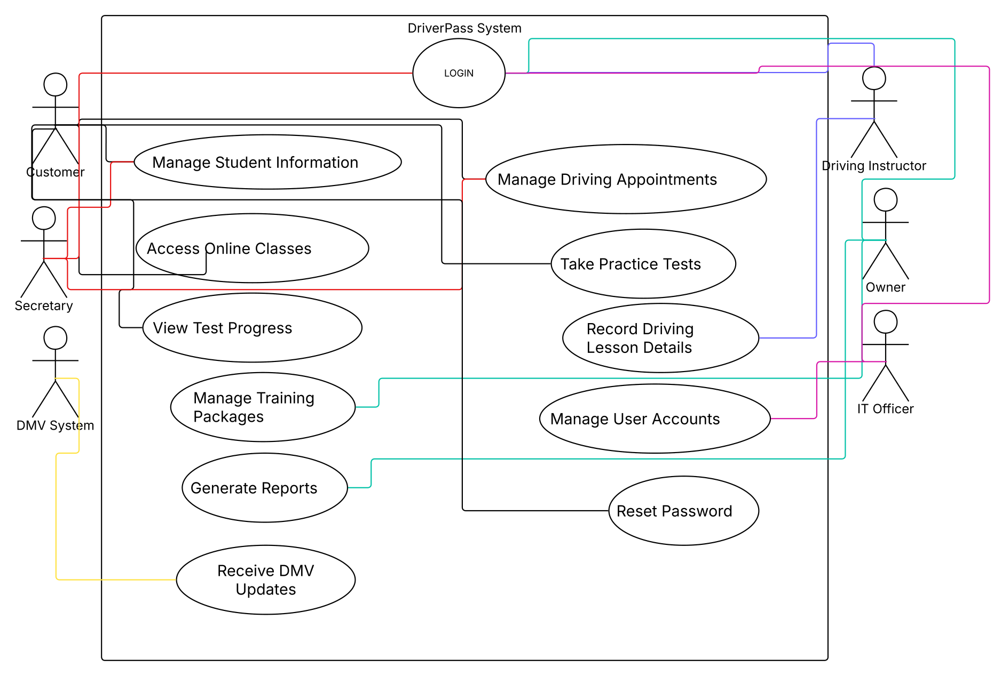

Activity Diagram 1: Schedule Driving Appointment
Follows the customer from login through date and time selection, availability checks, instructor and vehicle assignment, reservation tracking, and confirmation.
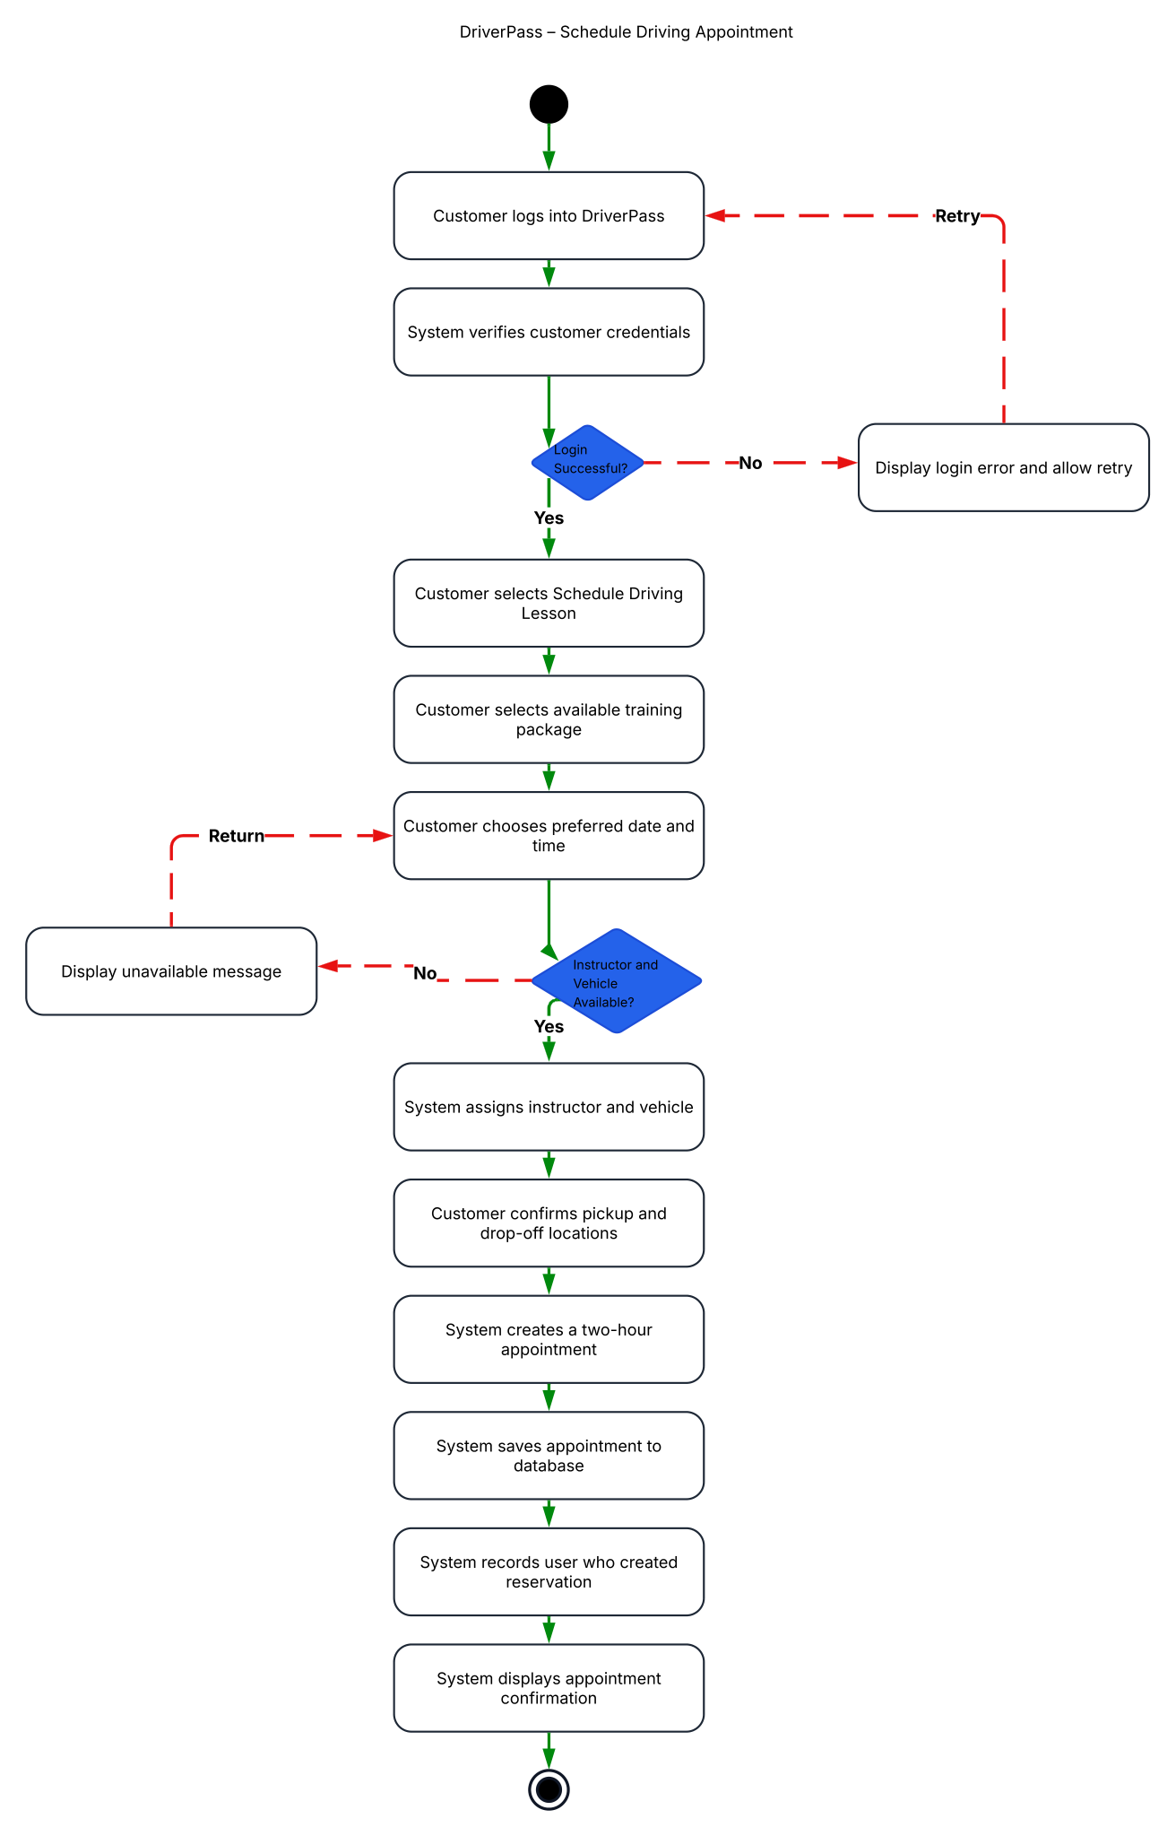

Activity Diagram 2: Take Practice Test
Shows Package Three eligibility, practice-test selection, test completion, pass/fail results, and saving the score and time taken.
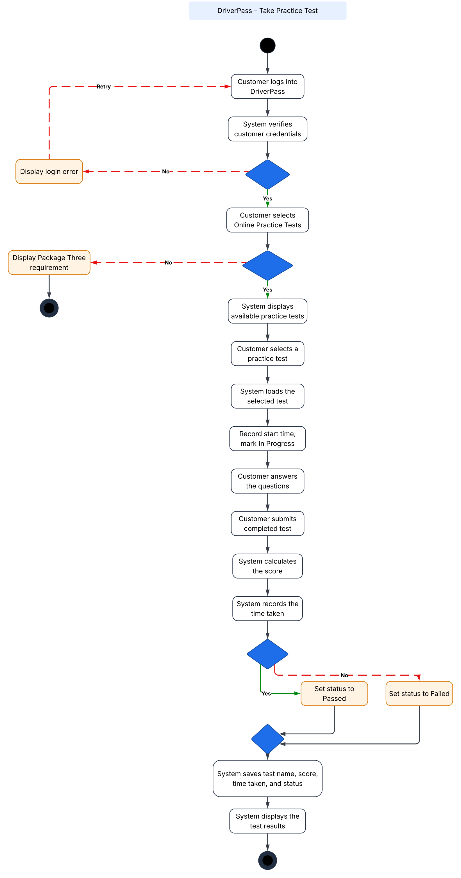

UML Sequence Diagram: Schedule Driving Appointment
Shows communication among the customer, website, scheduling service, and database, including appointment availability, alternate times, and cancellation.
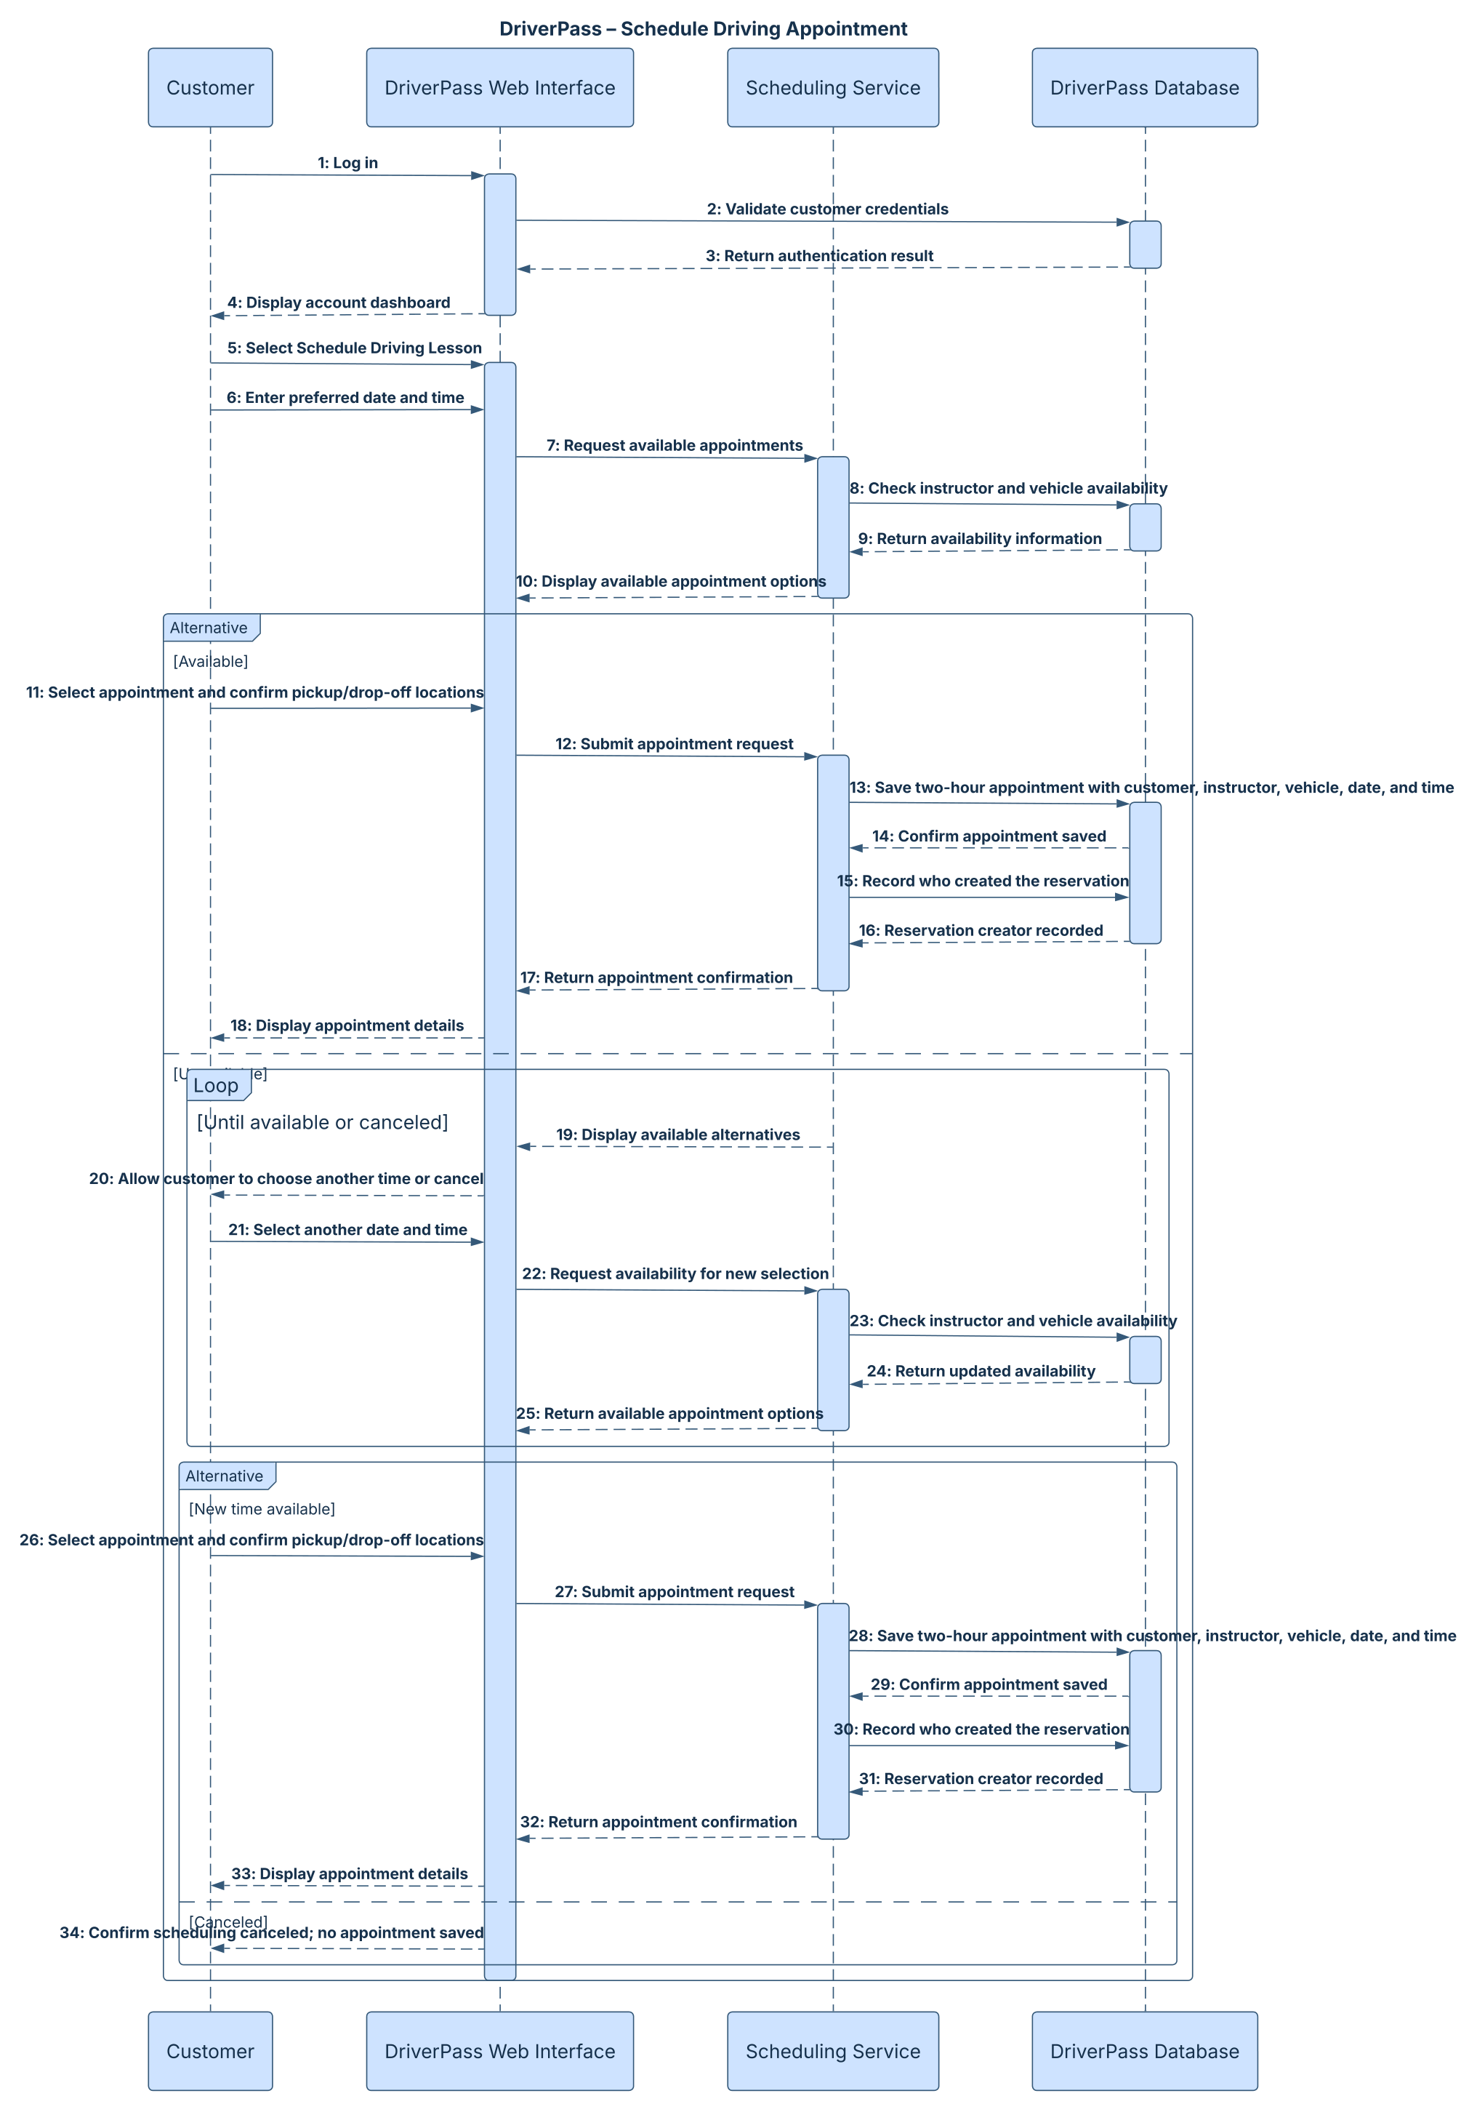

UML Class Diagram
Shows proposed classes, key attributes, and associations for accounts, customers, staff, appointments, vehicles, packages, tests, lesson records, and activity logs.
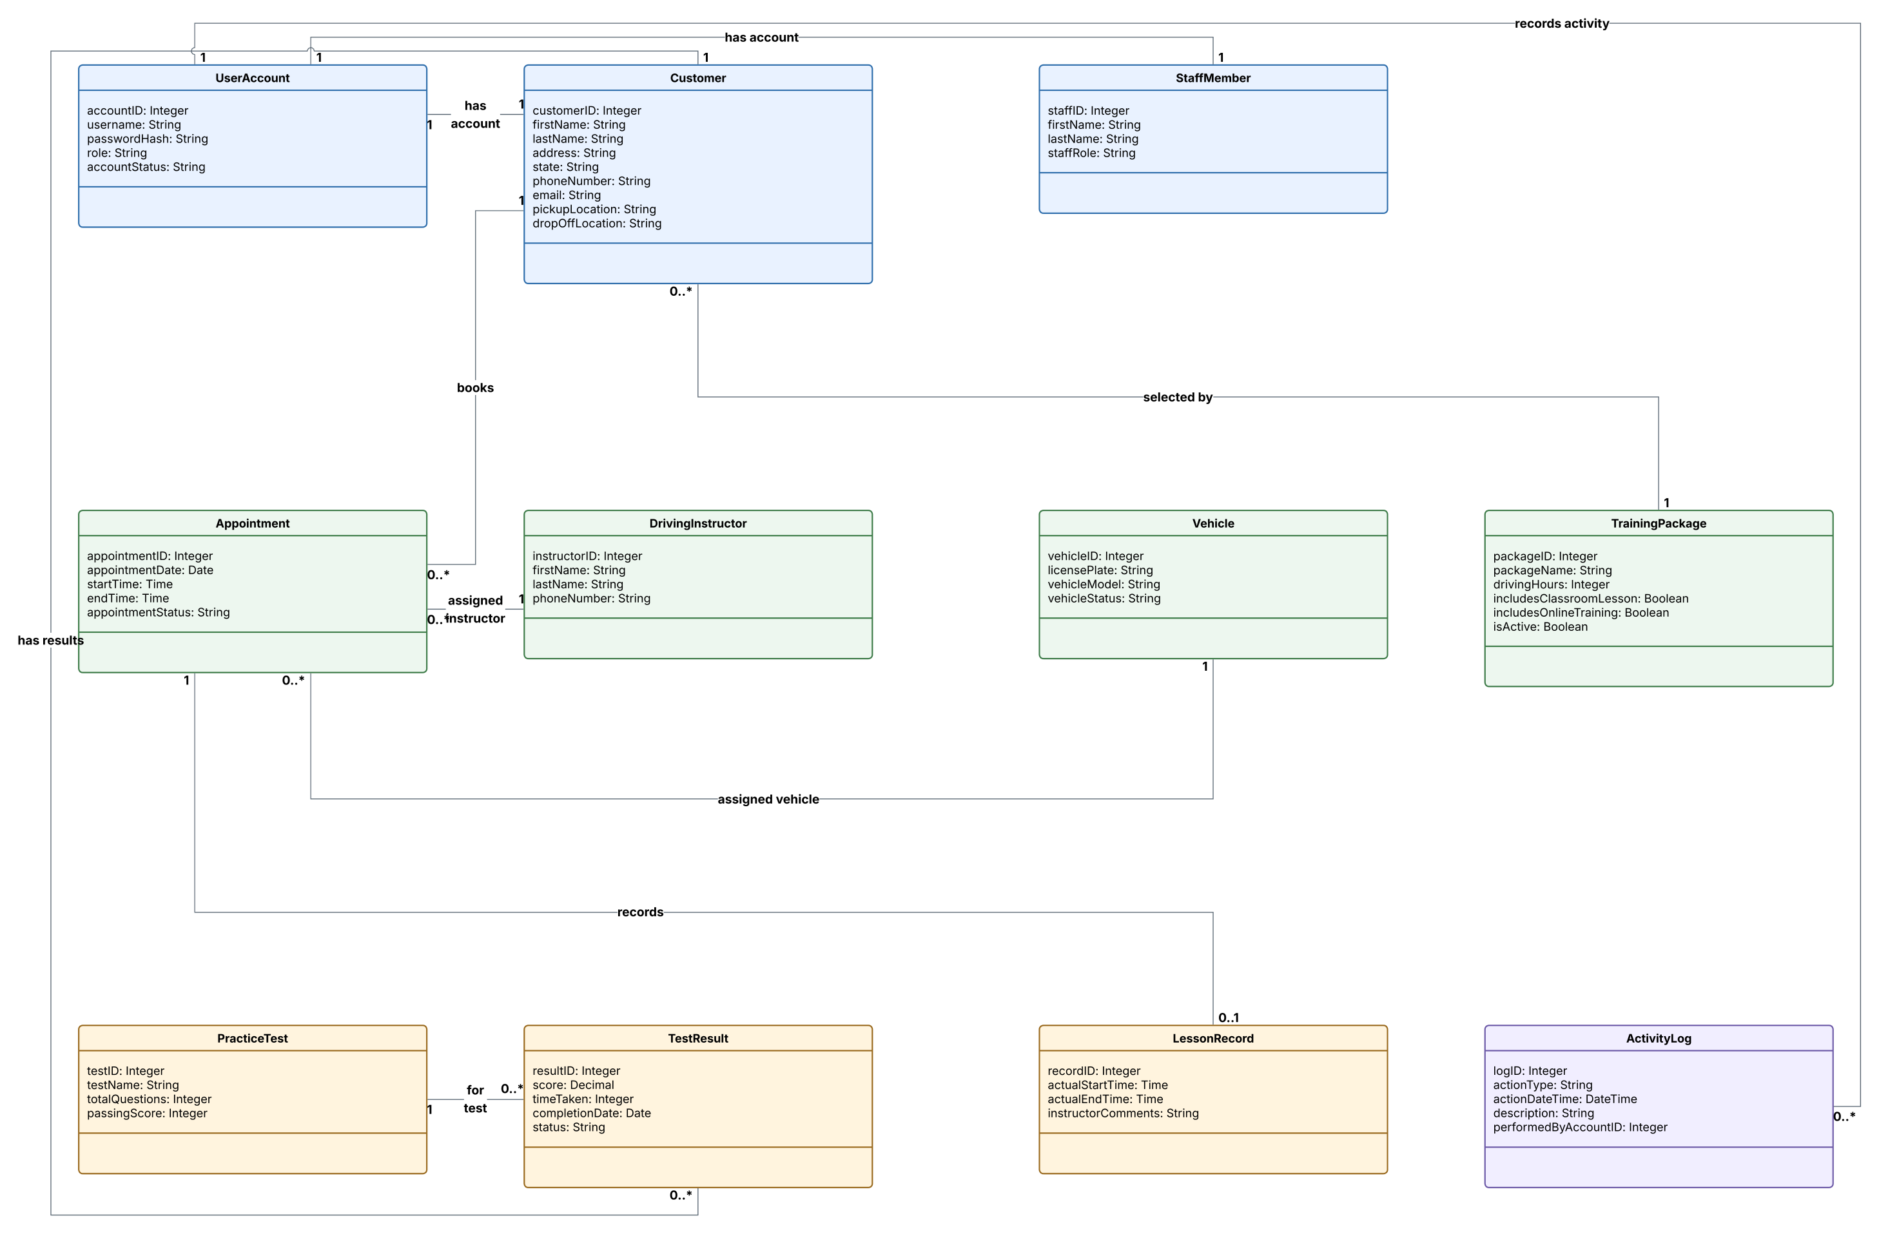

Technical Requirements

Hardware and devices
Customers and employees need a supported computer, tablet, or smartphone with a current web browser and a reliable internet connection. Driving instructors and office staff need devices for reviewing reservations and updating lesson information. The company will need its fleet information stored in the system rather than dedicated on-site application servers.

Software and application tools
Use a responsive web application with separate customer and staff interfaces. Implement account login, self-service password resets, role-based permissions, package management, scheduling, practice tests, result tracking, reporting, and activity logs. Use a relational database to maintain appointments, users, instructors, vehicles, packages, and test results. Provide spreadsheet-compatible report downloads for the owner.

Cloud infrastructure and availability
Host the application and database in managed cloud services with secure HTTPS connections, encrypted data storage, automated backups, recovery procedures, availability monitoring, and capacity to support customers using different devices. A central live database prevents conflicting offline edits; downloaded reports can be viewed offline, but updates require an online connection.

Security and payment information
Separate customer, secretary, instructor, owner, and IT officer permissions. The IT officer must be able to reset or disable staff accounts; customers must be able to reset their own passwords. Record who creates, changes, or cancels reservations. Store password hashes rather than plaintext passwords. Because registration requests payment card information, payment processing should use a compliant provider/tokenization approach; do not retain card security codes after authorization.

Scheduling and training business rules
Each driving appointment lasts two hours and must link a customer, instructor, vehicle, date/time, and pickup/drop-off details. Availability checks must prevent overlapping vehicle and instructor bookings. Packages provide six, eight, or twelve hours as described in the interview; Package Three includes online classes and practice tests. Packages can be disabled from new registration; adding entirely new modules is outside the initial release.

External updates, reporting, and implementation
Provide a DMV update integration or managed import mechanism for changed rules, policies, and sample questions, plus notifications when updates arrive. Track lesson times and instructor comments and store test names, time taken, score, and completion status. Development will require an IDE, source control, test environment, database tools, monitoring, and documented release/backup procedures. Specific cloud vendors and technologies are proposed during implementation, not mandated by the interview.

